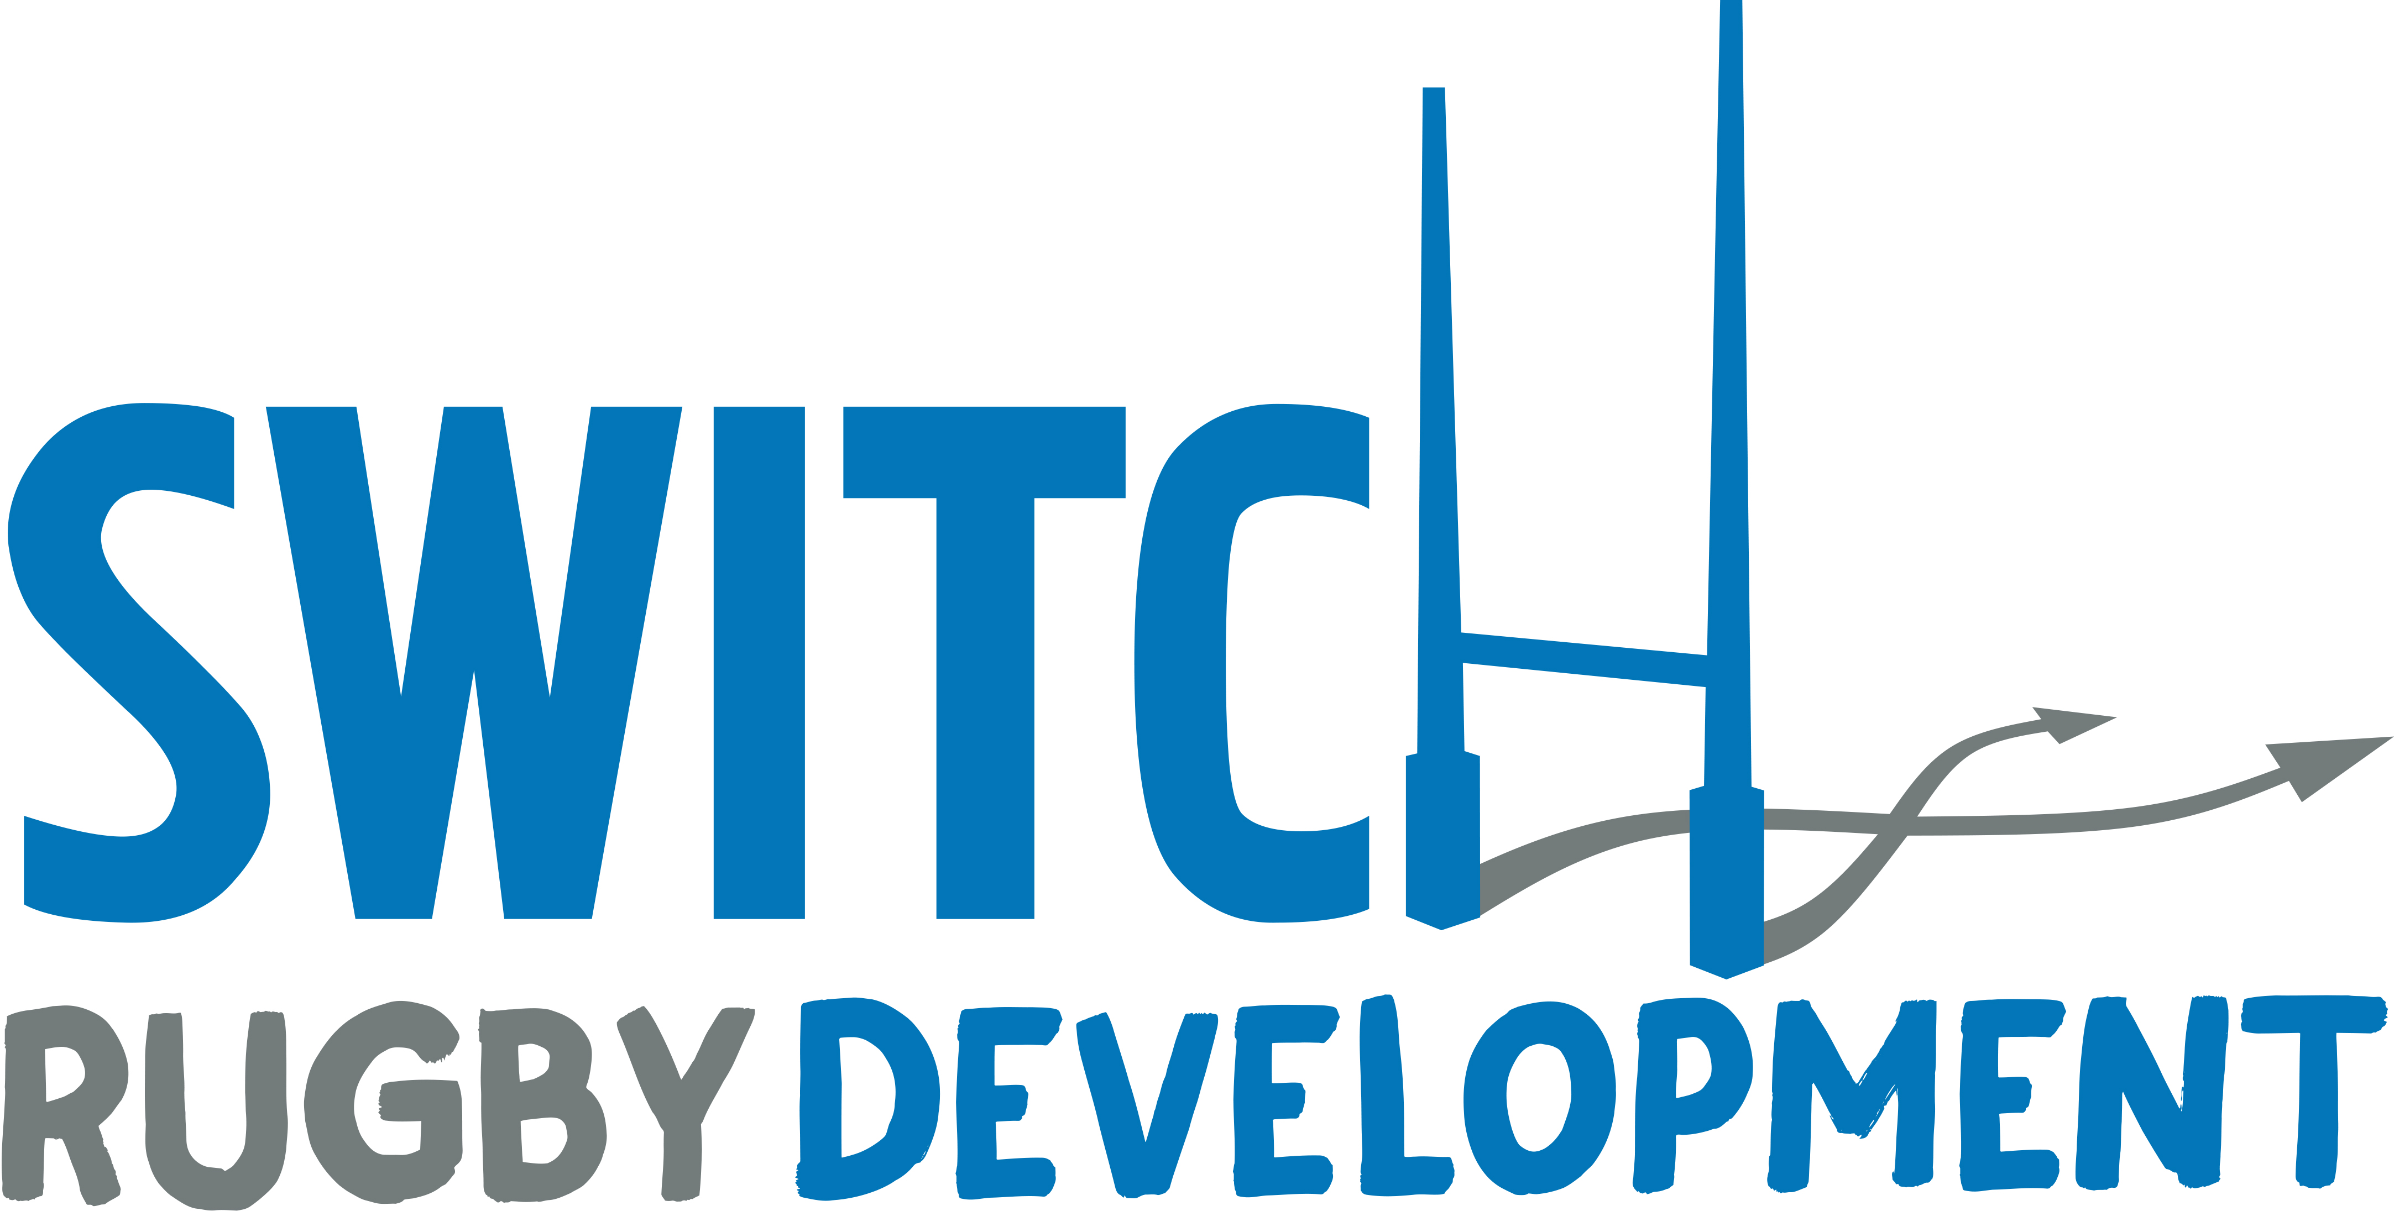
Booking Form

Price List

Basics  1 Day Session = £30  2 Day Sessions = £55  3 Day Sessions = £80 | Additionals  Early drop off from 8:30am - £3  Late pick up at 4pm - £3  Both Early and late pick up - £5

 | Basic | Additional (if required)
Date | Day session(s) required  (9am-3:30pm) | Early drop off ONLY from 8:30am | Late pick up ONLY at 3:30pm | Both Early and late pick up - £5
Monday, 28th October 19
Tuesday,
29th October 19
Wednesday,
30th October 19

Children’s Details (you can apply for two children)

Child 1: | Child 2:
Date of birth: | Date of birth:
Age: | Age:
Rugby Club: | Rugby Club:
School: | School:
Any Special Requirements/Medical Issues: | Any Special Requirements/Medical Issues:

Contact Details

Parent’s Name:
Address: | Mobile No.:
 | Email:
Post code: | Confirm email:
Emergency Contact Name: | Telephone:

Declaration

I give permission for my son/daughter to participate in the Switch Rugby Limited Summer Camps on the dates indicated above. I acknowledge that participation in this programme is undertaken at our own risk. I understand that whilst attending this programme, Switch Rugby Limited or its coaches accept no liability for personal injury, loss or damage to personal effects. I acknowledge and comply with Switch Rugby rules for the course.

I give permission for my child to receive any medical treatment necessary* Yes / No

I give permission for photographs to be taken of my son or daughter as promotional materials*
Yes / No

I give Switch Rugby permission to keep me informed of future Holiday courses via email.
Yes / No

I allow Switch Rugby to store my information in this form for booking purposes and contact me via email regarding my booking.
Yes / No

Please complete this form and return it via email using matt@switchrugby.com

Once sent you will receive email confirmation of your booking along with payment details.

